Overview
The project uses modularisation and functional decomposition to split the different tasks required. The main areas are the frontend, which involves the display, UI, and handling of user input; and the backend, which involves calculating and plotting the graphs, and processing the user input. The program runs from the file main.py, which mainly handles user input, and then utilizes other modules to link to the backend of the program and build the user interface.
Below is a list of all the different modules used in the program, with the highlighted ones being ones that I have coded myself:
Name | Type | Function | Details
pygame | library | display | Provides display, geometries and text rendering for UI
RPi.GPIO | package | hardware | Interfaces between Raspberry Pi pins and software
os | module | hardware | Used to send the shutdown command through the system shell
time | module | hardware | Used to provide buffer between button presses to avoid CPU stress
traceback | module | backend | Logs error messages
main | module | all | Handles user input and links other modules together
evaluator | module | backend | Creates lambda function from postfix expression and evaluates at given points
parser | module | backend | Creates postfix expression from tokenized infix
expression_tree | module | backend | Implements OOP system for inputting, rendering and evaluating maths expressions
math | module | tools | Provides mathematical functions
constants | module | tools | Stores commonly used variables and values
helpers | module | tools | Provides useful functions not project-specific
input_display | module | display | Handles rendering and moving in input mode
graph_display | module | display | Handles rendering and moving in graph mode

The modules are all generally interconnected, as can be seen by the below diagram (ovals are external libraries/packages and rectangles are part of the project)
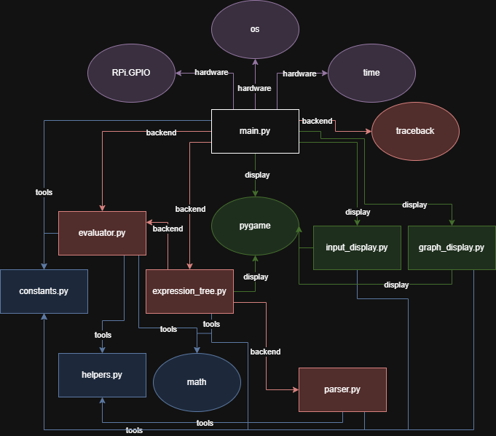
Main file (main.py)
The main file of the calculator runs based on a game loop of 60 Hz. The operations executed in each loop are triggered whenever the user presses a button, which causes the program to run through a series of conditionals to determine what to do next.
The calculator has two modes - input mode, which allows the user to enter equations to be plotted; and graph mode, which plots the graphs on a set of axes. I will explain each mode in greater detail further on.
At the start of the main file, there is a procedure reset() which initialises the program and is also called in case of an error so that the user can continue to use the calculator even if there is some bug. This is done through a try/except block wrapping the contents of the main loop and is helpful for avoiding the need to validate equations entered - if the parser cannot handle it, it will simply throw an error which will be caught by the block. This means that validation is only necessary once, as opposed to using it in every module. If an error is caught, it is written to a file logs.txt, which is helpful for later debugging.

The main variables initialised are shown below:
Name | Type | Values taken | Purpose
display_mode | String | “input” or “graph” | Sets the mode for which screen to display
functions | List of Expression objects (custom class) | Expression object | Holds objects for each of the 7 functions that can be inputted by the user
cursors | List of Cursor objects (custom class) | Cursor object with parent as corresponding function | Holds cursor objects for each of the 7 functions that can be inputted by the user
view_window | List of strings | String representation of a number | Holds the values for each of the 4 view window options that can be inputted (min and max for x and y)
selected | Integer | Integer between 0 and 10 | Currently selected function or view window field
cursor_active | Boolean | True or False | Whether the cursor is currently active (user is inside field)
shift_mode | Boolean | True or False | Whether the shift modifier is currently active
angle_mode | String | “RAD” or “DEG” | Which unit to use for measuring angles (when plotting trig functions)

The main file also contains a procedure render_graphs(), which, as the name suggests, renders the entered functions as graphs. This is called when switching to graph mode and can be thought of as the link to the “backend” of the program. Below is a high-level flowchart of the procedure:
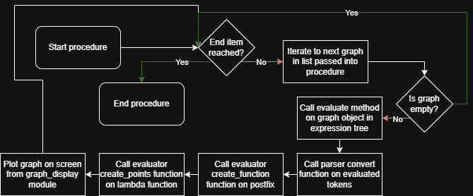
From the flowchart, we can see how this procedure links together most of the files in the program, effectively abstracting the actual calculations away from the user for the computer to render the inputted graphs.

Below is a flowchart of the workings of the main file:
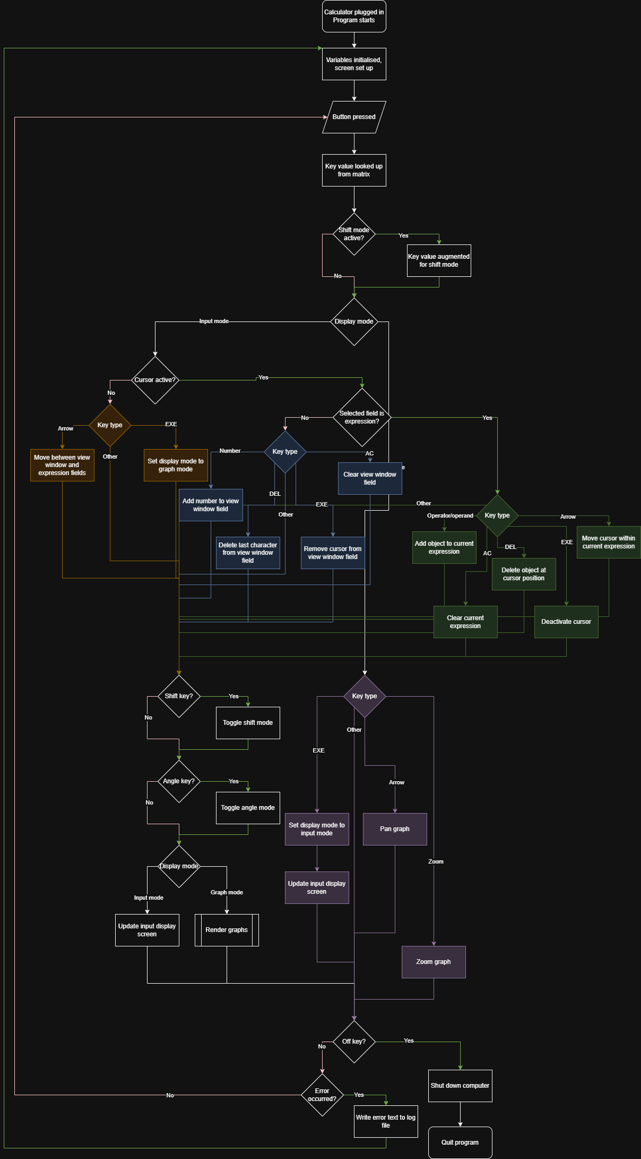
It can be seen that the program works from a series of conditionals testing the initialised variables to determine the mode of the user, and, if in input mode, whether the cursor is active or not, and then whether the selected field (if there is one) is one of the fields in the view window, or an expression field.
The distinction between the view window fields and the expression fields are primarily due to the difference in the way that they are stored - the view window, being just a number, is simply stored as text, with the cursor represented by a pipe character appended to the end of it. The expression fields were also initially represented in this way, but I have now refactored them to use a custom-built expression tree, allowing for more robust parsing and rendering, as well as allowing things such as nested radicals or fractions.

Next, I will talk briefly about the two modules that help with the actual display of the frontend for both the graph and input modes.

Input display (input_display.py)
The input display module has two functions - update_screen and move. These handle the Pygame rendering of the backend data and are called by the main file periodically to update the display.
The update_screen procedure takes arguments screen, functions, selected, view_window, cursors, cursor_active, shift_mode and angle_mode, and renders each of the functions onto the screen by calling their render method within the expression tree. The procedure also draws the boxes and fields for the data that will be rendered, as well as other graphics such as the colours for each function, and the shift and angle modes.
The move function handles the selection of fields and updates the passed in selected value as well as handling the cursor and appending it to the view window strings if necessary. The model that is used throughout the code is that the main file contains all the variables necessary, and these are then passed through each of the other files as needed.
I have mentioned the view window a few times - this is a set of 4 fields for minimum and maximum x and y values, and the user can input values in them to change the bounds of the axes that the graphs are plotted on.

Graph display (graph_display.py)
The graph display module similarly has functions update_screen and move, but additionally has plot_graph and zoom. The update_screen function simply draws the axes for the graph onto the screen, along with labels for the bounds of the axes.
The move and zoom functions work according to the same concept - the user input changes the bounds of the graph based on what they have done, and then the graph itself is recalculated and plotted with the new bounds. Both functions modify the variables for bounds found in the constants.py module, which also stores things such as the zoom scale factor and the width and height of the screen.
The plot_graph function works by taking the provided mathematical function, which is defined using lambda calculus (a system of functional abstraction defined in many programming languages, which essentially allows functions to be stored in a way similar to variables, allowing manipulation that is not possible with the usual way of defining functions). A list of points is generated at fixed intervals based on a frequency set in the constants.py file, which are x values, and are then fed into the function to give the corresponding y value. If a value cannot be generated (undefined mathematically for example), a None value is created instead. When the points are then plotted on the axes, a line is drawn between the previous and the current point if both are defined, which provides a system of linear interpolation to plot the graphs.
I had previously considered using other types of interpolation, but linear interpolation works well for my needs as it is quick and easy to calculate, and the frequency of points calculated is high enough that linear interpolation gives an approximation of the graph that is near-perfect. As the graph is recalculated at different zoom levels, the interpolation stays with the same frequency, which gives a consistent rendering of each graph.
One barrier I found was that at very high zoom levels, the numbers cannot be stored in binary as floating-point numbers without losing accuracy, as they become incredibly small, and this also puts a lot more strain on the CPU when storing the numbers as well. Unfortunately, there is no viable fix for this to allow infinite zoom levels as the computer simply is not capable of storing numbers with infinite precision. I have therefore capped the maximum zoom in, and similarly the maximum zoom out (again as the numbers get larger more bits are needed to store them which impacts the speed of the program). Additionally, the calculations take more processing power and thus time to do when the numbers become extremely small or large, which also impacts the speed of the program.

Helper files (helpers.py and launcher.sh)
I also have some lightweight helper files which provide key functionality for ease of coding. The helpers.py file firstly contains a function frange, which is a custom implementation of the range function but for floating point numbers, so that instead of having to manually scale the range to the bounds of the graph, I can call this function with the bounds and the frequency I want to generate the list of x values to plot.
The file also contains a class SafeList, which inherits from list, and simply returns a default value if the index is not found. This is helpful for my implementation of a queue and a stack for the parser, as I don’t have to handle edge cases in the parser itself. By moving input validation a layer down to the actual data structure, I don’t have to worry about handling it at the user level, which effectively abstracts it away whilst I am coding.
The launcher.sh file is a shell script that runs on the Raspberry Pi when the system boots up, and simply navigates to the folder which the program is stored in and then runs the main.py file, so that the program starts as soon as the user turns on the calculator. It does take a couple of minutes to boot up the system, but this is unavoidable with the current hardware, and it is unfeasible to keep the Raspberry Pi on all the time as I want the calculator to run off battery power, so leaving it on would drain the battery.

Constants file (constants.py)
The constants file, as referenced previously, contains lots of different constants and variables that need to be accessed by lots of different files within the codebase. It is helpful to have these all in a separate file as it means that nothing is hardcoded, so values such as the frequency of the graph sampling can be changed easily in only one place, which also eliminates redundancies. There are 3 main sections to this file - parsing, graph rendering, and input. I have kept a consistent style in this file with each variable being in all caps, which VS Code formats differently, which helps with readability and ease of development.
The parsing section contains lists that help the parser reference certain types of functions and manages order of operations. There is one list for right-associative operators, which are operators that evaluate from the rightmost one if chained together, such as the exponentiation operator. The only operator in this list currently is negation, as all of the main functions are now evaluated within the expression tree rather than by the parser, but the concept still holds. There is also a list for precedences, which contains the basic operators, and tells the parser which order they should be evaluated in. This comes with an associated procedure to convert the list into a dictionary so that each operator is given a number for precedence.
The graph rendering section contains a series of variables which define the bounds and other associated values for the axes that the graphs are plotted on, as shown below:
Name | Type | Default value | Purpose
DEFAULT_FREQUENCY | Integer | 300 | Number of samples of the function to take
WIDTH | Integer | 480 | Width of the screen in pixels
HEIGHT | Integer | 320 | Height of the screen in pixels
XMIN | Integer (can be float) | -15 | Minimum x bound
XMAX | Integer (can be float) | 15 | Maximum x bound
YMIN | Integer (can be float) | -10 | Minimum y bound
YMAX | Integer (can be float) | 10 | Maximum y bound
XDIFF | Integer (can be float) | 30 | Length of x-axis (XMAX-XMIN)
YDIFF | Integer (can be float) | 20 | Length of y-axis (YMAX-YMIN)
SCALEX | Float | 16.0 | Scales x values to pixels (WIDTH/XDIFF)
SCALEY | Float | 16.0 | Scales y values to pixels (HEIGHT/YDIFF)
X0 | Float | 240.0 | Where x=0 is on the pixel grid (-(XMIN*SCALEX))
Y0 | Float | 160.0 | Where y=0 is on the pixel grid (HEIGHT + (YMIN*SCALEY)
AXIS_LABEL_LENGTH | Integer | 3 | Size of axis labels
ZOOM_SCALE_FACTOR | Integer | 2 | How much to scale the axis by when zoomed
WSCALE | Float | 5/3 | Width scale for hardware screen (screen larger than expected)
HSCALE | Float | 3/2 | Height scale for hardware screen

These variables can all be edited as required to ensure a smooth display on the hardware screen, and are referenced primarily in the graph_display.py file when rendering the graphs. There is a procedure update_bounds which recalculates all of the above variables that are dependent on the bounds variables, so that any updates to the bounds are reflected in the other variables.

The input section of the file contains lists of each of the different types of inputs (unary/binary operators, numbers, symbols, variables, arrows, zoom, trig functions, brackets), which are used in the conditional logic in the main.py file to determine what to do with the user’s input.
It also contains a key matrix for each of the buttons. On the physical hardware, the buttons are implemented in a matrix, so both a row and column have to be triggered for each button (I will explain this in more detail in the hardware section). The constants file therefore contains pin numbers for each of the rows and columns, and then a matrix of values corresponding to each row and column, which is referenced whenever a button press is detected. When testing on my laptop, I instead have a dictionary of keys, which maps Unicode characters from keyboard presses to the key values, so that I can simulate pressing a button on the calculator.

In addition to these 3 sections, I also have defined some RGB tuples for colours used in the rendering, and the mathematical constants e and pi. There is also a list EDIT_TEXT which contains characters that are rendered next to the text in the view window as part of the UI (pipe for cursor and ellipsis).

Expression tree (expression_tree.py)

The main backend of the program is in the object-oriented expression tree. The tree implements every operator and operand that the user can enter, as well as methods to render and evaluate expressions, which are then passed through to the relevant modules, as I will show.

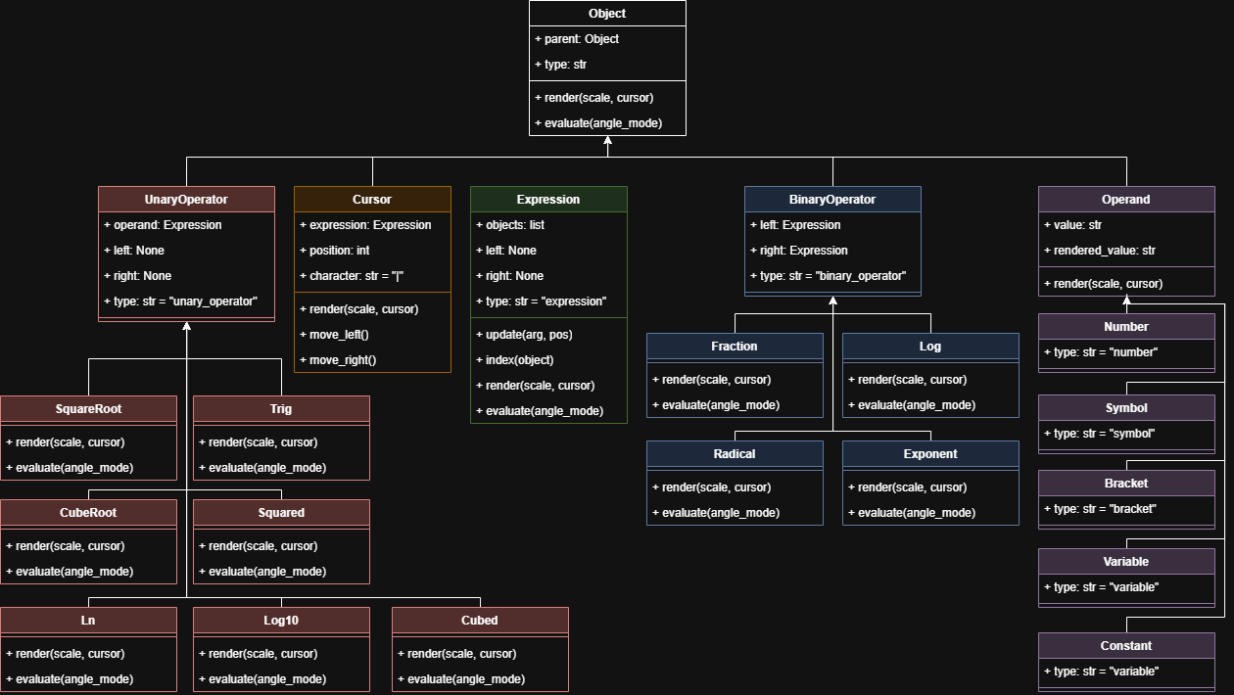
Below is a UML class diagram for the full expression tree:

It can be seen that the tree is rooted at the object node, which implements the parent and type attributes, and shells for the render and evaluate methods. Other subclasses are then grouped based on type, and the methods are implemented for each of them. Of note are the ways in which operands of functions are represented - every operand is an Expression object (which is in practice just a list of other objects). Binary operators have a left and right attribute, for the two operands which they contain, whereas unary operators have a single operand attribute.
The left and right attributes are implemented but defined as None for unary operators and expressions so that the program can modify the attribute if it exists, but access it regardless - this means that validation is not necessary for operators as the program can tell whether it is a binary operator or not by whether the left attribute is None.

The evaluate and render methods are defined for each object in the tree so that they can be called recursively. I handle the main operation of each method in the Expression class, and call the method recursively for each object in the expression.
Below is a flowchart for the evaluate method as implemented in the expression tree:
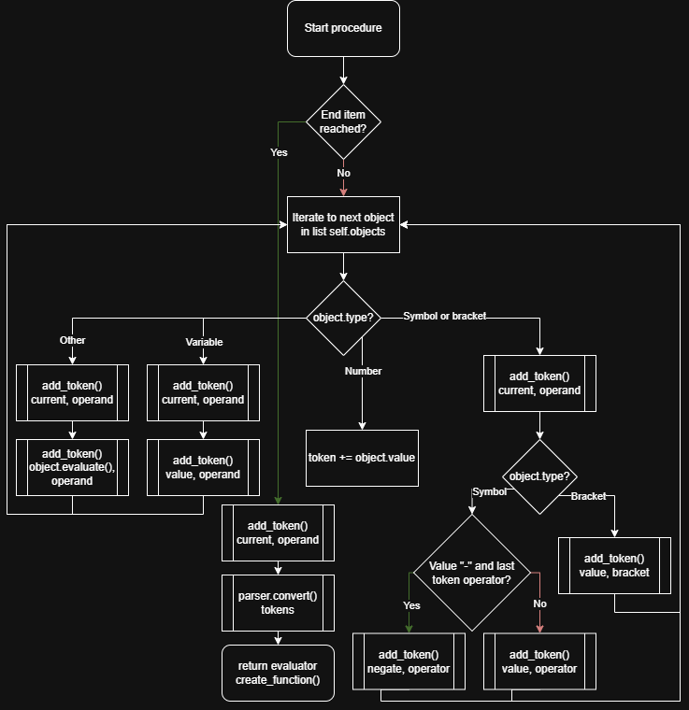
The add_token() procedure handles implicit multiplication and tags the tokens as they are added, so that in the parsing stage they can be more easily identified. Implicit multiplication is handled by considering each of 3 cases - an operand followed by a left bracket, an operand followed by a variable, or an operand followed by a lambda function (which is the result of calling the evaluate method on a unary or binary operator; essentially where a function would have been written in infix notation). For the purposes of this algorithm, a left bracket is treated as an operator and a right bracket as an operand, and the mathematical constants e and pi are treated as variables.
Unary negation is also handled by the evaluation algorithm, which adds it as a separate operator when tokenising rather than having to determine the type of operator a minus sign is at the parsing stage. This evaluation algorithm outputs a list of tokens, which are then converted by the parser from infix notation to postfix notation, and then evaluated by the evaluator module, which returns a lambda function. Because each component object also returns a lambda function when evaluated, the result of recursively calling the evaluate method is a single lambda function, which different x values can then be inputted into to get the corresponding y values.
The values returned by the functions (unary and binary operators) are mainly using the math module, or mathematical operators, and packed into a lambda function defined in terms of x. I experienced one problem when defining the calculations for radicals - a root of degree n will have n solutions by definition, however some of them may be on the complex plane, which is not useful for plotting real values. The roots are calculated by exponentiating the operand to the power of 1/n, which returns the principal value for each root - this can be a complex number. The solution I found for this is to take the absolute value of the operand in the calculations, and then change the sign afterwards - for example, the cube root of -8 gives 1 ± 𝑖√3 and -2, of which -2 is the only one we want, but one of the other two is the principal value - by instead taking the cube root of 8, which gives us the principal value of 2, and then negating it, we can get just the real-valued answer.

The rendering algorithm is less complex, but works recursively as well in a similar way. The render method for each object takes a cursor as a default argument so that if the expression is selected, the cursor can be passed through the function calls and rendered as necessary. The algorithm returns a single Pygame surface, which can then be rendered onto the screen in the correct field. Each object in the expression is rendered onto a new surface, which is then scaled to whatever size it needs to be, which is determined by the scale argument. This means that, for example, if an exponent operator needs rendering, the child expression for the exponent (which is the right child) can be rendered with scale 0.7, and it is then scaled down to match the surface.

Some problems with this approach are if nested objects such as powers or roots become too small on the screen - I have chosen not to fix this problem as it would require either capping the number of nests, which would not be a robust solution, or capping the scaling down at some point and adding a scroll mechanism so that the user can access all parts of the expression, which would not integrate very well with the current screen, and also would be a fair bit of work to implement.
There is a similar problem with the idea of scaling the expressions down, as they inevitably lose resolution in the scaling. I have introduced a dynamic font size for text that is rendered directly with Pygame, which helps to combat this issue, but for characters such as radicals, which I am drawing with Pygame’s geometry, it works better to scale down the object at the small cost of some sharpness than to attempt to draw the geometry as parametrized based on the scale of the object. Additionally, fixing this would require each object to know the overall size relative to the entire expression, not just the parent object, which is an extra variable to track and pass through the function calls and would make the code a lot messier.

Parser (parser.py)
The parser module has a single function, convert(), which takes a tokenized expression in infix notation, and, using the shunting-yard algorithm, converts it to postfix form. As the expression tree handles complex functions, this algorithm only needs to worry about the basic operators. Implicit multiplication and unary negation were also handled previously by inserting operators into the tokenized form where needed, so we do not need to detect these in the parser either. Each token consists of a value and tag pair, which tells the parser the actual value of the token, and what type it is for easy conditional checking.

The shunting-yard algorithm uses a stack to keep the operators on, and a queue to push the operands and operators to, which is returned when the algorithm terminates.
Name | Type | Purpose
out_queue | queue implemented as helpers.SafeList | Objects are pushed to it to create the postfix notation
operator_stack | stack implemented as helpers.SafeList | Operators are pushed and popped to it to move them so that the infix notation can be converted to postfix

We want the expression to be in postfix notation as order of operations is encoded, so it simply has to be evaluated from left to right, with operands stored on a stack and then popped whenever an operator is encountered. This also eliminates the need for brackets, which greatly simplifies the evaluation process.
The algorithm is called from the parser module on the tokens from the evaluate method of the Expression objects in the operator tree, and the result is then passed to the evaluator to return the lambda function that can be plotted on the axes.
Below is a flowchart of my implementation of the algorithm:
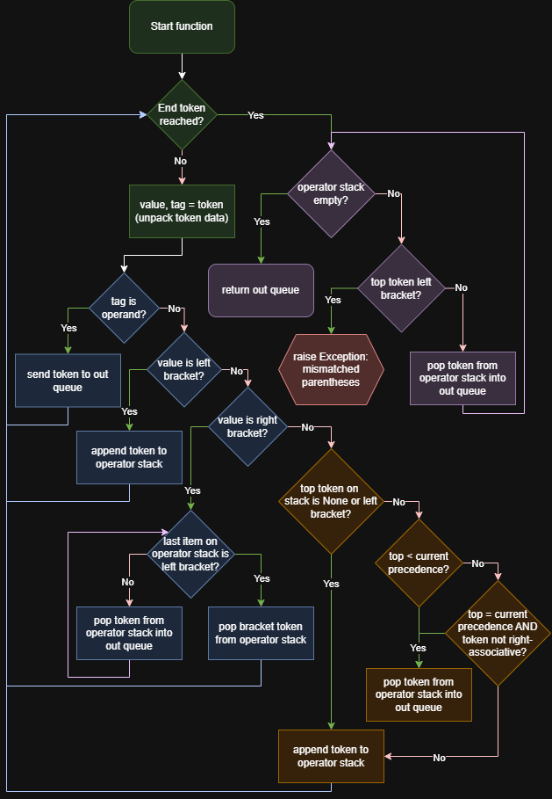
The module previously included a processing function, which took the expression as a raw string of text, and made heavy use of regular expressions to tokenise it: this was however a solution that was quite difficult to iterate upon and not very readable, and as a result there were numerous bugs and edge cases, and it was not robust. As I later created the expression tree, the need for this pre-processing no longer exists, because operators and operands are stored as objects, and they are tokenised where necessary in the actual expression tree before being passed through to the parser.
Previous versions of the convert() function also included checks for unary and binary functions, and brackets as part of function calls - as the expression tree holds functions as their own objects, they are evaluated previously, so are just treated as operands at the parsing stage.

Evaluator (evaluator.py)
The evaluator module is called directly after the parser, and takes the list of tokens in postfix notation, firstly creating a lambda function from them in create_function(), and then creating a list of (x, y) tuples which are plotted to the screen in create_points().
The evaluator (and expression tree evaluation) utilizes the concept of functional programming, by using first-class functions, whereby functions can be treated as other variables would be. In Python, this is done using lambda calculus. As functions are treated as variables, they can be passed into other functions: for example, if there was a function a(x): return x+2, I could then define a function b(x): return a(x)**2 - this would return whatever the value for a(x) is squared, so it is equivalent to b(x): return (x+2)**2. This is very powerful in my recursive method, as it means that functions can be created individually for each object, and then passed into larger functions to combine the entire expression into one function in the end.

The create_function() method works by iterating through each token, and pushing it to a stack if it is an operand. If it is an operator, it pops the last value (last 2 for binary functions) off the stack, and creates a lambda function with the operation applied to the operand, which is then pushed back onto the stack. This process continues until (if all goes well), the stack contains only 1 item, which is a single lambda function encompassing the entire expression. All the lambda functions are defined in terms of x - I would like to add implicit functions and parametric functions at some point, but I did not have time to add them to the main project.
A stack is useful for this algorithm as the postfix notation works by doing the operation on the previous operand(s), and a stack is a last-in-first-out data structure, so the previous operand will always be the first to be popped from the stack.
Previous versions of this algorithm implemented trigonometric and logarithmic functions as well, but as I have now created the expression tree, these are evaluated before reaching this stage, so there is no need to include them in this module.

After the lambda function is obtained, the create_points() function is called - this firstly generates a list of x-values using the helpers.frange() function, and then calls the function for each x-value, and appends the tuple of (x, y) to a list of points, which is then returned, to be passed through to the graph_display.py module, which will render them on the screen.

File structure

The project is broken down into 2 main folders - code and hardware. The code folder contains all of the software that I have written, as well as some font files as assets. There are slightly different versions of the code files in my actual project folder due to the difference between testing the program on my laptop and running it on the actual hardware, though the changes are minimal and so not useful to look at in detail.
The hardware folder contains 5 main sub-folders - assets, cad, design, pcb and production. These folders contain the files needed for the design of the PCB and the 3D models. The assets folder contains symbols downloaded from the Internet, which allow me to import the specific hardware I am using into the EDA software. The cad folder contains 3D models for the case that I have created myself, and the design folder has a rough layout for the buttons on the calculator. The pcb folder contains the files that the pcb is saved as from the EDA software, and the production folder contains the files needed for the PCB to be fabricated.
Below is a diagram of the file structure - I have coloured folders in orange, assets downloaded from the Internet in red, my code in green, and the hardware files that I have created myself in blue:
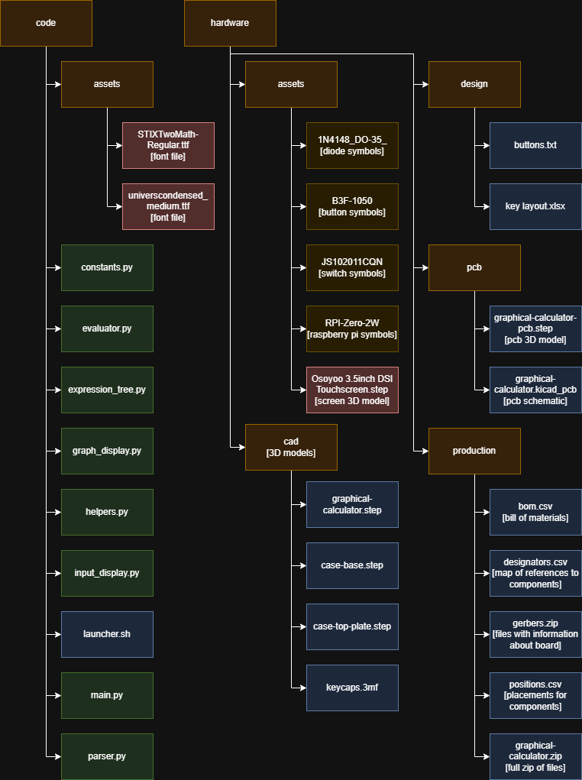

User interface

The user interface is designed to be quite simple, and easily understandable by the user. I have modelled it off similar interfaces on other graphical calculators, mainly the Casio fx-CG50, as I discussed in my initial analysis. As mentioned above, there are two screens - the input display and the graph display.
Below is a screenshot of the input display:
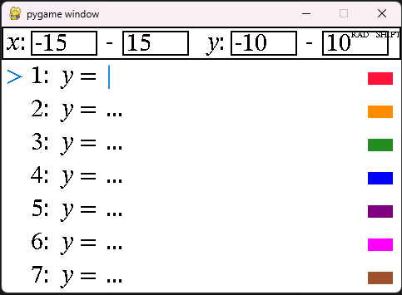
The angle mode and shift buttons are slightly overlapping with the input fields, but this is only with the resolution on my laptop - on the hardware they both look fine. I have chosen the colours specifically so that they show up well on the physical screen, and they are sufficiently different from each other, so they do not get confused. You can see above there is an indicator for the currently selected line, as well as the cursor. The view window is at the top of the screen, and the aim is that it is fairly intuitive as to what it does.
Due to the indicator and labels for the fields, it should be quite easy for the user to see what to do. The buttons are on the physical hardware, so very little input validation is needed, and as they are physical buttons it should be obvious to the user that they can press them. There is ample feedback when the user presses buttons, with the field updating with the mathematical expression, and the angle mode and shift indicators changing based on the user input. No memory load is needed for the user, as they are only restricted by the physical buttons that can be pressed - otherwise they have freedom to enter whatever expression they want, and it is validated at the evaluation stage.
There are no text prompts for the user, but the language used for labels is standard mathematical language which should be easily understandable to an A-level maths student, my end user. The display is also consistent in styling and input - the same screen is returned to from the graph display mode, and the inputting for the view window and the expressions is the same.
The end user needs to be able to easily input mathematical expressions, and the position and layout of the physical buttons allows for this, as I have tried to make them as similar to already existing calculators as possible.

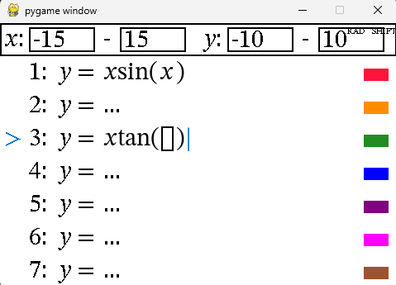
You can see above how the expressions inputted show an empty box for fields that have not yet been inputted by the user, and how the user can navigate between the different fields. Within each expression, the user can use the left and right buttons, and in the main screen, they can use the up and down buttons, and enter to select - this should hopefully be fairly intuitive.

The graph display screen can be seen below:
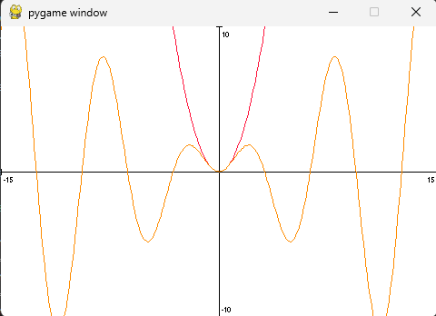

It is a fairly simplistic minimal design, and allows multiple graphs to be plotted on it at the same time. There are axis labels for the bounds, and the axis is drawn in - apart from that, it is empty, so as to not confuse the user or clutter the screen.
A-level maths students, the end users, will be familiar with graphs, so this screen should make sense to them, and the colours being consistent with the input display screen helps with this. The EXE button can be pressed to return to the input display screen - as the user has already had to press this to plot the graph, which logically makes sense, it should be easy for them to realise that they have to press it again to return. This screen should therefore be easily understandable by the user.

Validation

As discussed, as the calculator is a physical device, the only inputs that the user can enter are the physical buttons, so they are quite heavily constrained. Because of this, the need for input validation is highly reduced.
The main input validation that I have is a try/except block covering the entire game loop, which logs any errors to a text file before resetting the program. This is sufficient to handle the majority of errors that may be encountered. I also have a try/except block around the view window bounds calculations, to catch things such as 0 width ranges resulting in a division by zero error.
In my helpers file, I have a class Safelist, which returns a default value if a value is indexed that does not exist in the list, so I do not have to handle errors for the algorithms that implement this for queues and stacks.
Again, as the user is severely restricted in how they interact with the program, there is no need for further validation.

Hardware

The hardware I have used is primarily a Raspberry Pi Zero 2W, as discussed in my initial analysis. I have found that it works well for my needs, as I have loaded the Raspbian OS on, in which I am able to run Python and Pygame programs. I can SSH into the device to put the code onto it, and I have created a shell script (launcher.sh) to auto-start the program on boot. The buttons are the Omron B3F-1050 switches as discussed in the analysis, which have good tactile feedback and work well. I have 3D printed keycaps for the buttons - a problem here is that the size of the buttons and thus the keycaps means that the text printed on them is quite small, however I believe it is still readable, and I always have the option to write the text out on paper and affix it to the keycap for maximum readability.
I have 3D printed a case, which is not perfect, but I will be iterating on it to enable the design to be more compact. Some challenges I came up against were measuring the calculator for the case, as it is not a perfectly cuboidal object, and also when soldering the board, I initially soldered all 40 switches 90 degrees perpendicular to where they should have been, as, unbeknownst to me, the model for the switch in KiCad had accidentally been turned round by 90 degrees. Thankfully, I had enough extra components to resolder the whole board - I decided to do this on another board rather than attempt to desolder components first as this would have taken longer.
To create the PCB, I had to firstly create a wiring schematic, as seen below:
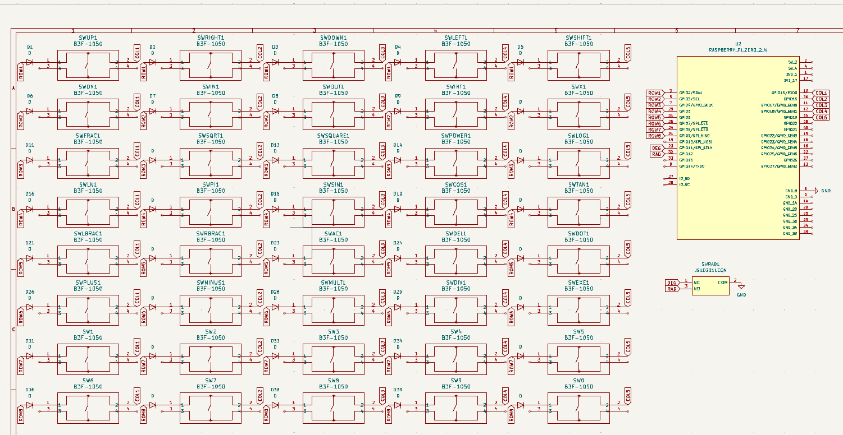

This involved finding symbols for each of the components on the internet and then connecting them in the program.
After this, I created the PCB model, where I had to arrange the components on the board and then put in the wiring, as below:
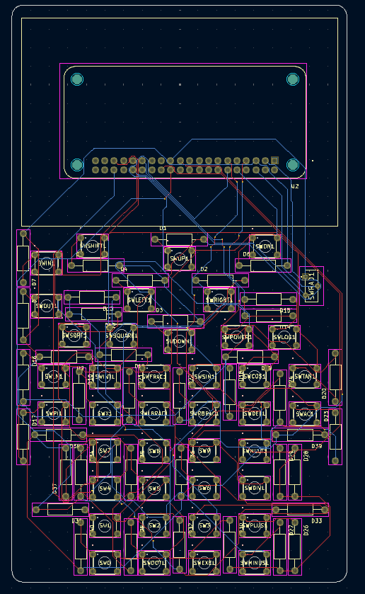

Finally, I created a 3D render of the completed PCB, which I then imported into Fusion360 to create a 3D model of the case around it, as well as the keycaps and top plate.
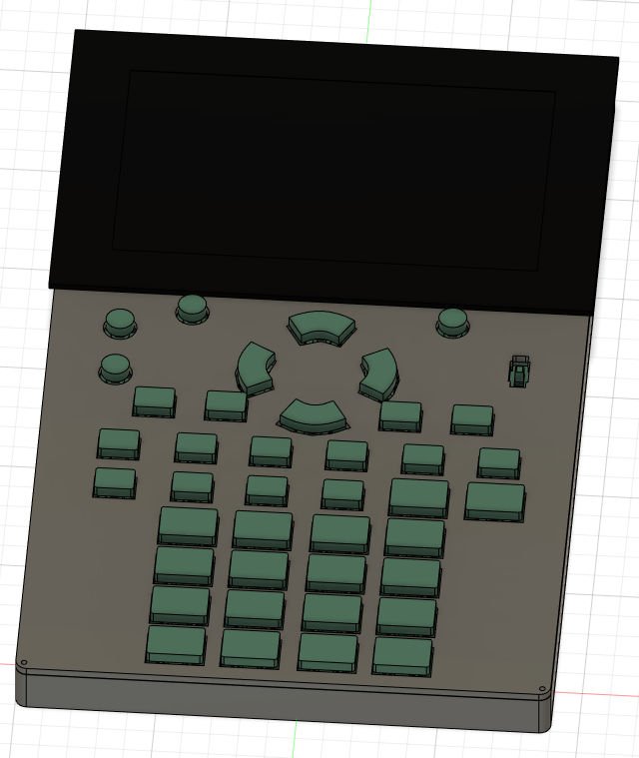
I could then 3D print the case and keycaps to build onto the full calculator.

